5-Whys Root Cause Analysis
Course Enrollment Failure
Instructions: Use the failed enrollment request captured in browser DevTools. Complete every field, make each Why follow logically from the previous response, and attach a readable Network-tab screenshot.
Tester | Student | Date | 2026-08-08
Test cycle | [Project/Team] _ [Sprint/Version] _ [Test Type/Phase] | Browser | Chrome 143
Application | MindBridge | URL | http://localhost:3000

Observed symptom
A date of birth of 01-01-1970 was entered on the MindBridge course enrollment form and "Enrol now" was selected. Enrollment did not complete and no confirmation was displayed. An inline error reading "data format mismatch" appeared below the field, even though the field's own helper text states that MM-DD-YYYY is an accepted format. The browser console recorded the request to /api/enrollment returning 400 (Bad Request).

Technical evidence from DevTools
Request method and URL | POST http://localhost:3000/api/enrollment
HTTP status code | 400 Bad Request
Request payload | [CAPTURE REQUIRED - DevTools > Network > api/enrollment > Payload tab. Paste the JSON request body showing the DateOfBirth field as transmitted.]
Response body | [CAPTURE REQUIRED - DevTools > Network > api/enrollment > Response tab. Paste the 400 error body returned by the server.]
Evidence screenshot | 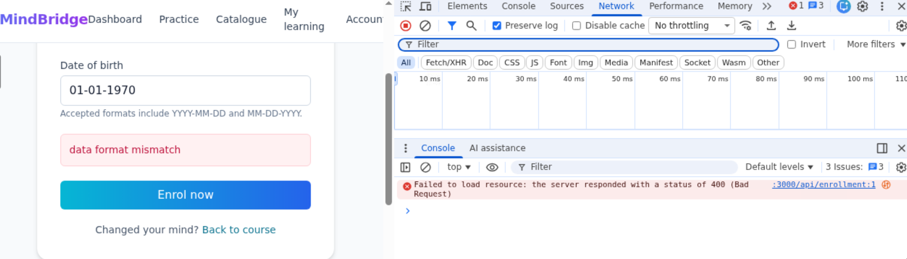

5-Whys analysis
Level | Question | Evidence-based response
Why 1 | Why did this happen? | The enrollment request submitted from the form was rejected by the server rather than processed: the console records the call to /api/enrollment returning 400 (Bad Request), and the interface displayed "data format mismatch" instead of an enrollment confirmation.
Why 2 | Why did the previous condition occur? | The server returned 400 because the DateOfBirth value carried in the request payload failed server-side input validation, so the request was rejected at the validation boundary before any enrollment processing took place.
Why 3 | Why did the previous condition occur? | The submitted value 01-01-1970 failed validation because the endpoint parses DateOfBirth only as ISO-8601 (YYYY-MM-DD). A hyphen-separated value that leads with the month or day is not recognised by that parser, even though 01-01-1970 is a well-formed MM-DD-YYYY date.
Why 4 | Why did the previous condition occur? | The client sent a value the API cannot parse because the form applies no normalisation before submission - it forwards the string exactly as typed - and its helper text advertises "YYYY-MM-DD and MM-DD-YYYY" as accepted, a wider set of formats than the API actually implements.
Why 5 | Why did the previous condition occur? | The advertised and implemented formats diverge because no single date-format contract is agreed and enforced between the enrollment UI and the enrollment API. The helper text and the server validation rule were defined independently, and no contract or integration test covers the MM-DD-YYYY case, so the mismatch went undetected.

Root cause
The enrollment API validates DateOfBirth strictly as ISO-8601 (YYYY-MM-DD), while the enrollment form advertises MM-DD-YYYY as equally acceptable and transmits it unconverted. Any non-ISO date is therefore rejected with HTTP 400 - including 01-01-1970, a value the interface explicitly tells the user is supported. The root cause is the unreconciled date-format contract between client and service, not the data the user entered.

Corrective action
Establish ISO-8601 (YYYY-MM-DD) as the single canonical wire format for DateOfBirth and enforce it at both ends of the call.
In the client, parse the entered value against each advertised format and convert it to YYYY-MM-DD before the request is sent, rejecting genuinely unparseable input inline rather than allowing a round trip that can only fail. If instead the API is to accept alternate formats directly, extend its parser to handle each advertised format with an explicit, documented disambiguation rule for values such as 03-04-1998, where day and month are interchangeable.
Whichever side is changed, three supporting fixes are required: the helper text must list exactly what the service accepts; the validation error must name the offending field and the required format rather than returning the generic "data format mismatch"; and the agreed format must be recorded in the API specification and covered by a contract test so the two sides cannot drift apart again.

Verification plan
Re-run the two failing cases from the test cycle against the fixed build, submitting 01-01-1970 and confirming that enrollment completes, the confirmation message is displayed, and /api/enrollment returns a 2xx status. Inspect the request in DevTools to confirm the payload carries a normalised YYYY-MM-DD value.
Regression coverage should include: ISO YYYY-MM-DD, which passed previously and must not regress; the advertised MM-DD-YYYY; the unadvertised formats DD-MM-YYYY, DD/MM/YYYY and MM/DD/YYYY, which must fail with a clear field-level message rather than a generic error; an ambiguous value such as 03-04-1998 to confirm the documented disambiguation rule; invalid dates such as 13-45-1970 and 2026-02-30; the leap-year boundary 2000-02-29; and an empty date field.
Finally, re-execute the full five-case cycle in Zephyr and confirm that Pass Rate returns to 100% and Defect Density to 0.00 on the metrics dashboard, and verify that the helper text and the API specification agree on the accepted format set.

